To: Professor Adarsh Kesireddy

From: William Songer

Assignment: Assignment 1

Date: 1/31/22

**Assignment 2**

**Assignment 2_1**

**Code**

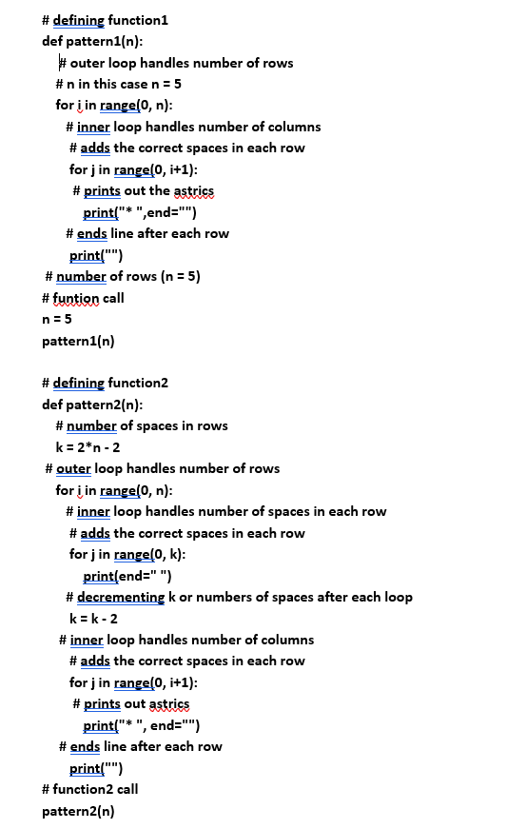

**Program output**

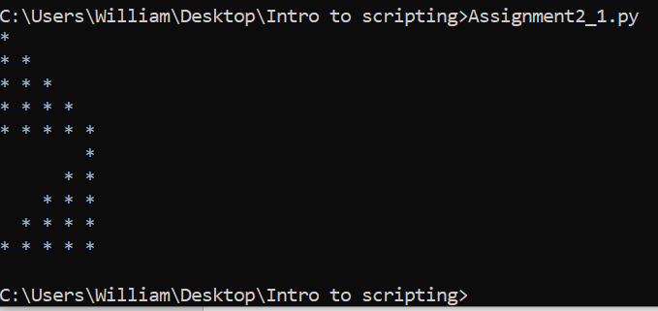

**Assignment 2.2**

**Code**

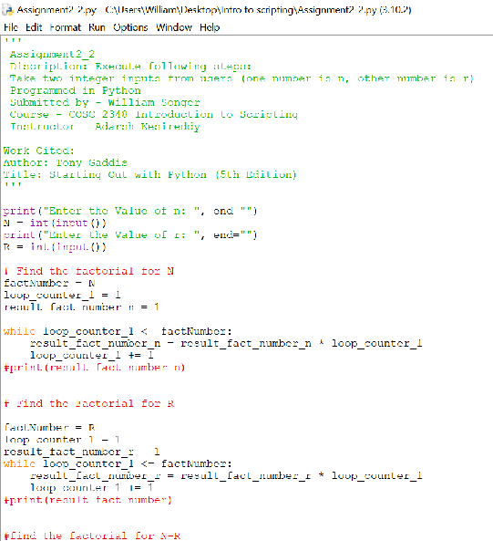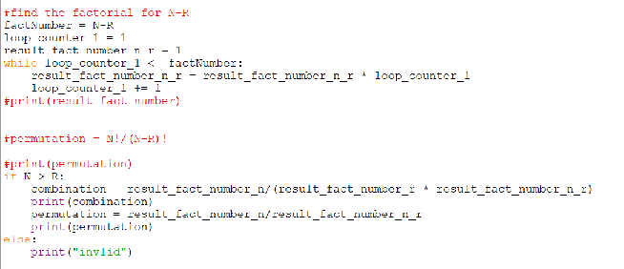

**Output**

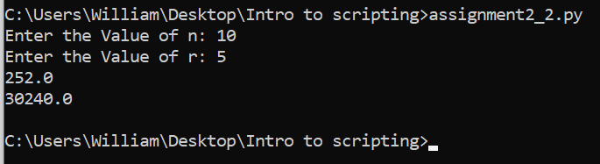

**Assignment2_3**

**Code**

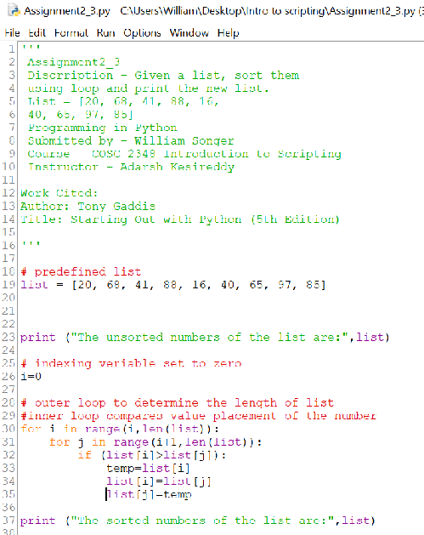

**Program output**

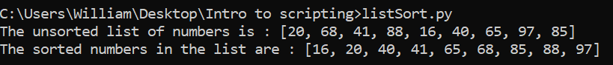

**Assignment2_4**

**Code**

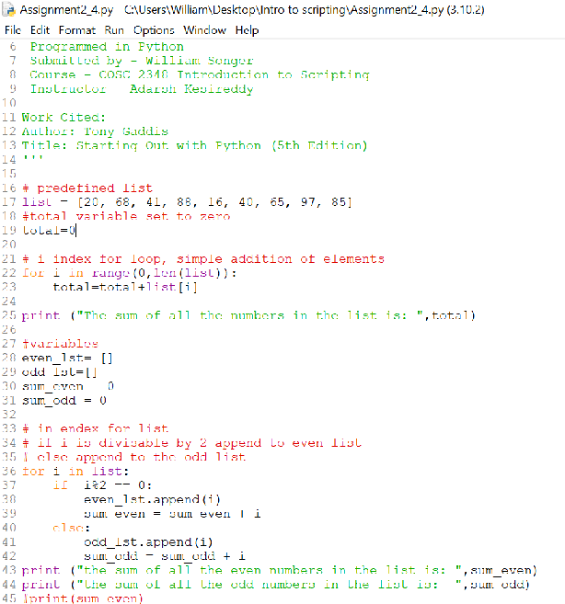

**Program output**

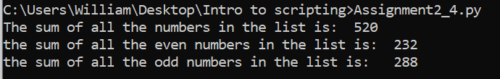

**Assignment2_5**

**Coding**

**Assignment2_8**

**Coding**

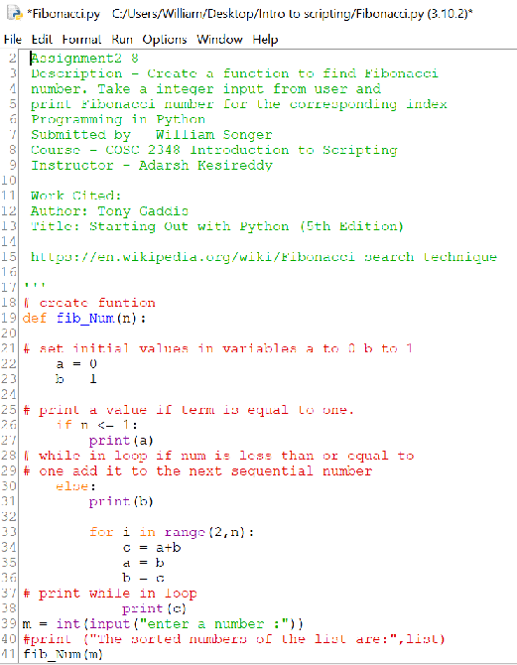

**Program output**

